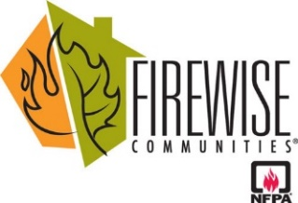
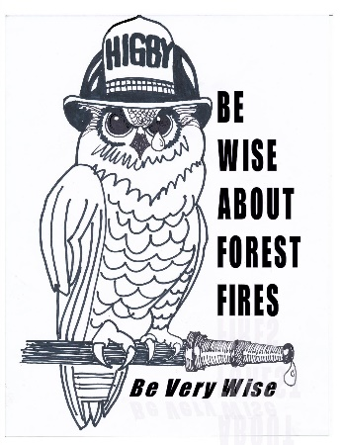

Higby Firewise® Notes – January 2022
Firewise = to be knowledgeable and prepared for wildfire.

Wildfire Season is Year Round
The recent fires in Boulder County should serve as a warning that fire season is now year-round and not just something that occurs during the dryer summer months. We continue to see red flag days throughout the winter so it’s important that we stay diligent as even snow coverage is not necessarily an indicator that wildfire conditions are low.
Winter – A Good Time for Wildfire Mitigation Projects! Get a Lot Evaluation This Winter a Lot Evaluation helps determine the potential vulnerability of your home during a wildfire. Recommendations will be made as to actions needed and mitigation methods to reduce the risks of damage to your home in the event of a wildfire. Now is a good time to get your lot evaluated so you can plan your mitigation work for the remainder of the winter and the upcoming spring. Mitigation is an ongoing effort and is best accomplished with a clearly defined plan. To schedule a ‘Site Visit’ lot evaluation, call the Colorado State Forest Service [CSFS] at 719-687-2921. The evaluation takes about 1 hour and costs about $50. Start Mitigation as Weather Permits. Snow cover can sometimes give you a better perspective on the density of your forest, so you can plan your pruning and thinning projects. Some winter days can be warm with decent weather, making it pleasant to get outside to do some work. Just remember to please be careful not to slip in the snow when cutting and hauling slash! Tree companies may be less busy and charge less in the winter if you need some help.
Reverse 911 Signup
To receive reverse 911 calls in the event an emergency evacuation is ordered, you must sign up to receive the emergency calls.
Please take the time to go to ElPasoteller911.org and sign up to receive emergency notices. In the middle of the page is an “Emergency Notifications” icon that will take you to the appropriate location to sign up for this important service. You can enter multiple phone numbers and request calls as well as texts when an emergency notification has been issued. You will only get these for the physical address you enter when you sign up.
Reduce wildfire risk before the fire starts. Be smart, be safe, be Firewise.

